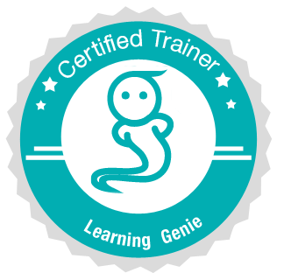
Prior Training - Admin Setup Guide

Prior to your training, it is very important for the admin/director to complete setting up the accounts for the teachers!

1. Setup class and add teachers manually
Director Tasks: ETA 15 minutes
❏ Sign up with Learning Genie at www.learning-genie.com (Click “Sign up for NEW center” ).
❏ Add a classroom (or multiple classrooms)
Web Portal Tutorial
❏ Add teachers to their corresponding classrooms, and provide teachers with the teacher
code that has been generated.
Web Portal Tutorial
❏ Add students to their corresponding classrooms ( Tip: You can add an entire class at
once from the web portal ).
Web Portal Tutorial

❏ Prepare and download the latest app (search Learning Genie) from Google play for Android device or App Store or iPad
❏ Ensure the devices are connected to the wifi at the training site

❏ Select Ambassador teachers (up to two per site) for future refresher courses

Teacher Task: ETA 2 minutes
❏ Sign up with Learning Genie (Click “Got a teacher code? Join your center.” )

- Import from DRDP-Tech directly
Director Tasks: ETA 15 minutes
❏ Sign up with Learning Genie at www.learning-genie.com (Click “Sign up for NEW center” ).
❏ Click Import from 3rd-party program
❏ Click Import from DRDPtech and follow the instructions from the link

