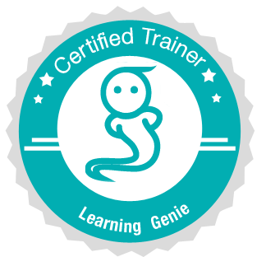
Learning Genie Certified Trainers
Training Prep Checklist
Pre-requisites:
- Wifi in the room of a training is an absolute necessity
- Being able to connect your device to the projector is an absolute necessity
      - Often time the projector is on the ceiling, this needs to be known
      - Older projectors and new projectors have different connections
      - Doc Cams are an excellent way to project screen without cables

Action Item | Person Responsible | Date Completed
Schedule the Workshop and Register the Participants
- Contact the agencies/ centers to determine a date for the workshop.
- Send a workshop invitation to participants
- Develop a registration system (google form works well, you can use eventbrite.com as well) and keep a list of participants who register.
- Send a finalized date and time of your training to support@learning-genie.com. Learning Genie Inc will arrange our staff to provide supports remotely if needed.
- Secure a location for the workshop. The room should accommodate small groups at tables with sufficient space for materials, with strong Wifi signal, and should support the use of a projector or big flat display. Make sure you have connectors for your smart devices are compatible with the projector (e.g. Lightening to VGA, Lightening to HDMI, Mac to VGA, etc)
Setup Learning Genie Account for Trainee
- Center/School admin should follow Pre-training Director’s checklist to Sign up with Learning Genie
- Admin should add a classroom (or multiple classrooms)
- Admin should add teachers to their corresponding classrooms, and provide teachers with the teacher code that has been generated.
- Admin should add students to their corresponding classrooms
- Teacher’s sign up to their classrooms
Hardware Preparation for the training
- Since it is a very hands-on training on mobile devices, each participant shall bring either a Android tablet or iPad/iPad mini during the training.
- A connector for your device to a projector. (iPad2 - 4S, iPad5, Android)
- Download the latest Learning Genie Educator’s APP (from google play or App store) to the devices.
- All devices connect to the wifi

