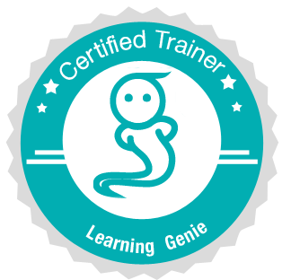
Training Plan
(SAMPLE)

Topic: Add an entry to a child's portfolio

Objectives: (the trainees will be able to...)
- Record an observation for a child's portfolio
- Tag appropriate domains
- Add a photo or a video
- Share entry with child's family members

Materials:
- A photo of a child building blocks
- A short narrative of the photo
- Tablet devices for all trainees
- Tablet device for self
- Observations from trainees (for the challenge)
- Rewards for Genie Challenge

Procedures:

- Ice-Breaker: "Who am I?" - Trainees each have a piece of paper taped on his/her back (with a child’s book character written on it). They have to ask questions about his/her character to figure out what he/she has. (Examples: Pete the Cat, The Very Hungry Caterpillar, Olivia, The Cat in the Hat…)

- Introduction: The trainer should state the following: “One of the most challenging aspects of early childhood education is being viewed as a ‘babysitter’ instead of as a professional. Having documentation of what children are learning in your classroom can help families see the value of a quality early childhood program. You can create a personalized portfolio for each one of your students and share it with the families. In addition, you can use the portfolios for assessment purposes.”

- Hands-On Activity: The next step is to have the trainees create an entry together using the block example. Have trainees look at the photo of children playing in the block area. Have the trainees discuss the block photo and what is happening in the photo. Encourage the trainees to use objective language when describing the photo. Then, have trainees go through the process of recording the observation and tagging it with corresponding measures using the below steps:
1. Select Portfolio→ Select child→ type an objective description in the comment area
2. Tap on corresponding measures
3. Tap on picture/video icon and select the block area photo
4. Tap “share in daily report”

- Genie Challenge: Ask the trainees to create their own entry using an observation from their classroom. Have the trainees include a photo, tagging domains and sharing the entry with parents.

- Wrap Up: Ask trainees if they have any questions and thank them for participating. Have trainees discuss their comfort in recording these kinds of observations and offer supportive comments. Distribute rewards for the Genie Challenge.

