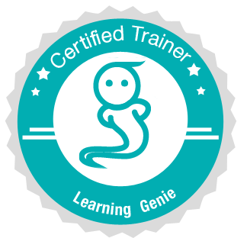

Icebreakers!
Learning Genie Certified Trainer Workshop

- The Toilet Paper Game
Each participant is handed a strip of toilet paper at random. The amount of toilet paper squares each person has will determine the amount of facts he/she must share about him/herself

- Hey, me too!
One person (usually the workshop leader) starts off with naming some facts about themself. When one of the participants hears something that is the same for them, they get up and stand next to the original person and then start giving facts about themself until someone joins them.

- Yummy Facts
Choose a candy like M&Ms or Skittles and assign a category to each color. For example, yellow=favorite movie, orange=favorite food, green=embarrassing moment, blue=share a funny classroom memory. Each participant is handed one (or a few, depending on how many you have) and must state facts about themselves according to the color(s) they received.

- Two Truths and a Lie
Each participant names three facts about him/herself, two of which are true, and one is false. The rest of the participants vote on which one is the false statement. See how many people you can stump!

- Question Circles
Each participant thinks of one good open-ended question. It can be teaching-related, for example: "What is your best advice for building good relationships with parents?" or personal, for example: "If you could have lunch with one famous person, who would you choose and why?" Divide your group into an inside circle of people who face an outside circle of people. The two people facing each other take turns asking their question and listening to the answer. Then, after about a minute or so, have the inner circle rotate so they can ask a new person their question and answer a new question, as well.

- Comic Strip Chaos
Select a number of multiple-frame strip cartoons from the Sunday funnies. Cut them into individual frames. Place the frames in a container. Each participant picks one comic frame from the container. After everyone has a frame, the participants begin to search for others with the same comic strip sequence. After the participants have found everyone in their group, they must arrange themselves so that the sequence of frames is in correct order. Upon completion of sequence, the newly formed group sits down together. This is a great way to break large group into smaller groups.

- Alphabet Search
Each person finds a partner, if possible, someone they don’t already know. Every pair must find items (in the room, in each other’s purses, etc.) that correspond with each letter of the alphabet, in order. So, you can’t search for a “B” item until you have found an “A” item. Each team will write these down on a sheet of paper as they are found. The workshop leader can specify an amount of time, and when time is up, the team who reached the most letters of the alphabet wins!

- Ha ha ha!
Participants form a circle. The object of this activity is, without laughing, to pass the word “ha” around the circle, increasing repetitions each time. For example, the first person will say “ha,” the second person will say “ha ha,” the third person will say, “ha ha ha,” and so on, until someone can’t complete the pattern without laughing! This is a great way to warm everyone up, since laughter is the best medicine!

These are just some ideas for inspiration. Feel free to use any of our suggested icebreakers, create new variations, or come up with a completely different one! The goal is just to help people feel comfortable. Have fun!

